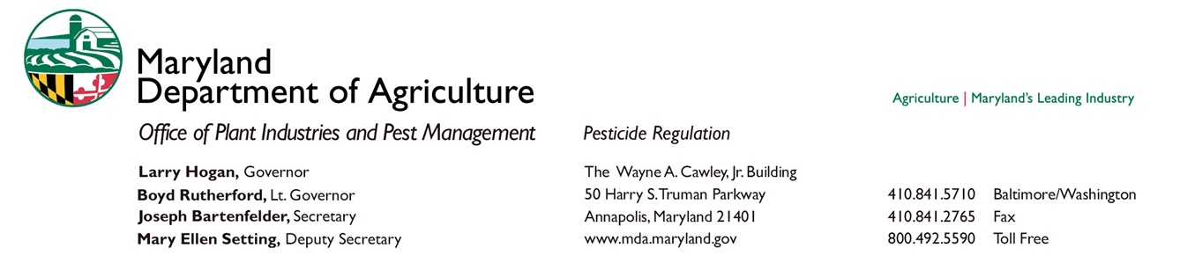

MEMORANDUM
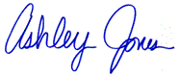
TO: Interested Parties
FROM: Ashley Jones – Entomologist, MDA
DATE: April 16, 2015
SUBJECT: Support for the Development of Maryland’s Managed Pollinator Protection Plan (MP³)

The Maryland Department of Agriculture has teamed up with the University of Maryland Apiary Program in the beginning steps of developing Maryland’s Managed Pollinator Protection Plan or MP³ for short. If you are not familiar with MP³s, here is a brief background on their conception:

The most important piece of Maryland’s MP³ development process will be the engagement of stakeholders. Opening lines of communication with numerous groups within the beekeeping industry is an integral part of creating a successful and sustainable pollinator protection plan. In order to plan and implement these stakeholder meetings, we are currently in the process of obtaining grant funding through the Specialty Crop Block Grant Program. For submission, we will need letters of support from groups, organizations, and/or individuals with an interest in pollinators and activities that impact them. Therefore we are requesting your assistance. Attached is a simple layout of a support letter we could use to strengthen our application. If you do support this cause and would like to utilize the attached letter by inserting your own information or create your own letter, we would be very appreciative.
The union of this many representatives spanning so many groups within this industry is something that has yet to occur in Maryland. This is a very exciting time for the Maryland beekeeping industry!
We are very grateful for any support that comes our way. If you would like to send a letter, please fill in the blanks on the template with your information or feel free to create your own letter. Then either mail the final letter to the address on the template or email a copy of the letter to me, Ashley Jones at <Ashley.jones4@maryland.gov>. Unfortunately the deadline for submission is rapidly approaching. We request letters to be sent in by May 4, 2015.
Please know that by sending this letter, you are not obligated to attend the stakeholder meetings. We will certainly extend the invitation when the time comes, but there is no commitment required.
Thank you so very much for your time and assistance!

