Maryland State Beekeepers’ Association
Fall Meeting
September 11, 2010
Universities at Shady Grove,
Rockville, MD

8:30am | Refreshments, Coffee, Donuts, etc.
9:30am | Opening and Welcome | Paul Dill  President
9:45am | Md. Apiary Inspector's Report --CANCELLED | Jerry Fischer  Md. State Inspector
10:00am | House Hunting by Honey Bees  A study of effective group decision making | Dr. Thomas Seeley  Author, The Wisdom of the Hive  Cornell University
 | Break
11:15am | A Zoning Victory for Honeybees and Beekeepers: The Prince William County, VA Story | Karla Eisen  Prince William County, VA Beekeepers
12:00 noon | Lunch (not provided on site)
1:30pm | Baltimore Honey: Community Supported Apiaries and Sustainable Urban Beekeeping | Meme Thomas, Director of Baltimore Honey www.baltimorehoney.org
2:15pm | Getting Freebies:  The design and use of effective bait hives | Dr. Thomas Seeley  Author, The Wisdom of the Hive  Cornell University
3:15pm | Panel discussion: Wintering Nucs
4:00 | Adjourn

Our Speakers:

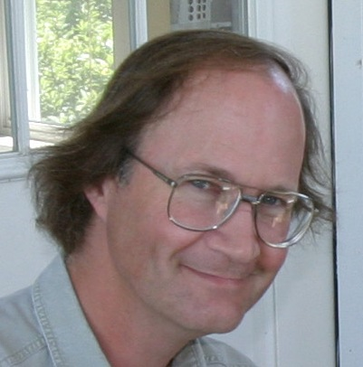
Dr. Thomas Seeley is Professor and Chairman in the Department of Neurobiology and Behavior at Cornell University. He is a world authority on animal behavior, especially the social behavior of honey bees. At home more in the field than the laboratory, his scientific work features observational and experimental investigations of the inner workings of honey bee colonies living under natural conditions. A member of the American Academy of Arts and Sciences, he is the recipient of numerous honors for his scientific work including a Guggenheim Fellowship, the Alexander von Humboldt Distinguished U.S. Scientist Award, and a Gold Medal from Apimondia for his book The Wisdom of the Hive. Currently, he is working on a new book, Swarm Intelligence in Bees.

Karla Eisen is Secretary of the Prince William Regional Beekeepers (PWRBA) in Northern Virginia, and was a leader in the successful initiative to revise zoning laws to open doors to beekeeping in the full range of neighborhoods in this highly diverse county in 2009. She is also active in efforts to promote local, sustainable beekeeping through techniques such as overwintering nucleus colonies and recently completed directing a Sustainable Agriculture Research and Education (SARE) grant "Promoting Sustainable Beekeeping through the local production of nucleus colonies."

Meme Thomas is Director of Baltimore Honey (producers of the B'More Honey brand, www.baltimorehoney.org) as well as a successful landscape business owner whose pioneering model of community supported apiaries (CSAs) will be expanding into additional Maryland communities over the next year or so. Meme is committed to sustainable beekeeping and beekeeping in urban and suburban environments.

Directions:
The Universities at Shady Grove are located near I-270 exit 6B (MD Route 28 W/Darnestown). From the exit, merge onto W. Montgomery Ave./MD-28 W. Turn LEFT onto Darnestown Rd. Turn LEFT onto Shady Grove Rd. Turn RIGHT onto Gudelsky Way. Turn LEFT onto Gudelsky Dr. Parking available in lots 1 and 2 on your left.
Please visit https://shadygrove.umd.edu/about/visit/directions#ba for directions from further afield.

Get the latest information on MSBA activities at our web site at www.msbeea.org

###
LUNCH: We are not able to offer meals other than coffee service on site during our September meeting. We encourage you to either bring lunch or visit one of several nearby restaurants.

