Maryland State Beekeepers’ Association Spring Meeting
June 15, 2013
University of Maryland/College Park
Plant Sciences Building

The MSBA Spring Meeting is open to the public.

8:30am | Refreshments, Coffee, Donuts, etc.
9:30am | Opening and Welcome | Dr. Wayne Esaias  President
9:45 | Md. Apiary Inspector's Report | Md. State Inspector
10:00 | The Pursuit of the Perfect Hive: Why and How Beekeepers Innovate New Solutions | Dr. Gene Kritsky  College of Mount St. Joseph
11:00 | Defending Managed Pollinators Using Advocacy, Advice, and the Law | Michele Colopy  Program Director,  National Pollinator Defense Fund
11:30 | Lunch
1:00 | Local Research Project: Efficacy of splitting and swarming of hives to increase overall survival | Katy Ciola Evans,  Graduate Researcher,  University of Delaware
1:30 | Hive Development throughout History and Around The World | Dr. Gene Kritsky  College of Mount St. Joseph
2:30 | Panel/Group Discussion: Should MSBA Adopt A Position on the Banning or Regulation of Neonictinoids? What strategy is best for the bees? | Dr. Wayne Esaias, Steve  McDaniel, Beth Passavant,  Dr. Galen Dively (UMD),  Michele Colopy
3:30 | Adjourn | Dr. Wayne Esaias  President

MSBA Spring Meeting 2013 Speakers
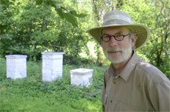
Dr Gene Kritsky is Professor and Chair of Biology at the College of Mount St. Joseph, Adjunct Curator at the Cincinnati Museum Center, and Editor-in-Chief of American Entomologist. He received his PhD in Entomology from the University of Illinois in 1977, his MS in Entomology from the University of Illinois in 1976, and his BA in Biology from Indiana University in 1974.
In his recent book, The Quest for the Perfect Hive, Dr. Kritsky offers a concise, beautifully illustrated history of beekeeping, tracing the evolution of hive design from ancient Egypt to the present.
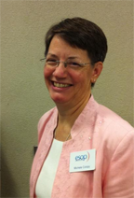
The mission of the National Pollinator Defense Fund (NPDF) is to defend managed and native pollinators vital to a sustainable and affordable food supply from the adverse impacts of pesticides. They accomplish this mission by ensuring that states and the EPA enforce regulations to protect pollinators from pesticides, and other strategies, including litigation, petitions, and technical support for those who have suffered damages to their beekeeping operations. NPDF provides advocacy, guidance and tools for beekeepers , and raises awareness about the adverse impacts of pesticides on pollinators.
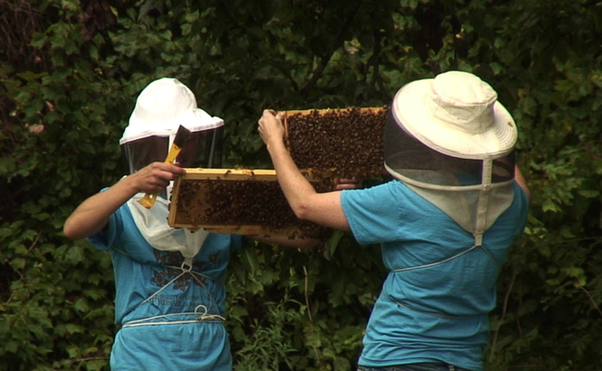
Michele Colopy, Program Director of the NPDF, has more than 17 years of experience in a variety of nonprofit organizations, including the performing arts, housing and homelessness, foreclosure prevention, community development, and health and wellness areas. Her father raised bee for his small apple orchard in Ohio.
Katy Ciola Evans is a native Floridian with a Bachelor’s degree from the University of Florida and several years experience working as an African Honey Bee lab technician with the FL State Apiary Department. She has just finished her second semester as a Master’s student at the University of Delaware Apiculture program. For her Master’s project she is developing an ‘Integrated Pest Management’ (IPM) program for beekeepers in the mid-Atlantic region with the goal of reducing varroa populations.

Dr. Galen Dively is Professor Emeritus and Integreated Pest Management (IPM) Consultant at the University of Maryland/College Park. Prior to his retirement in 2006, he worked in extension and research, specializing in integrated pest management, non-target risk assessment, and pesticide resistance management. His extension work involved the development and implementation of IPM projects to reduce pesticide use in crops.
Dr. Dively works part-time and is involved with in-state and national training activities to meet the continuing educational needs of agri-chemical personnel, crop advisors, county extension educators,and producers. He has been a favorite contributor to past MSBA meetings and it is a pleasure to welcome him again this Spring!.

